Tylney Park Golf Club

Rotherwick, Nr. Hook, Hampshire, RG27 9AY

Tel: 01256 - 762079

MIXED OPEN 18 Holes
Team Event 4 Ball Betterball Stableford
(Team – 1 Lady 1 Man)

Sunday 7th August 2022
Entry fee - £80 per pair
(Inc. coffee on arrival and a two course meal)

Closing date for entries: Monday 18th July 2022.
No entrance fee will be refunded once received unless a substitute is found

Handicap Limit – Men 28 Ladies 36 (*competition handicap required)
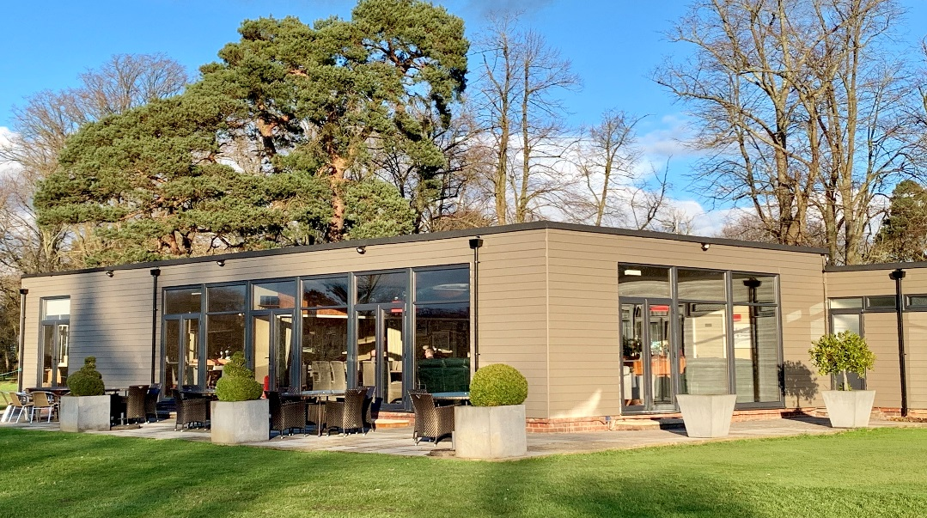

Please complete and send off the application form below with your cheque and a stamped addressed envelope if you don’t have an email address. Tee-off times will be e-mailed out w/c Monday 25th July 2022. Cheques payable to ‘Tylney Investments Limited’

To: FAO Paul Archer,
Tylney Park Golf Club, Rotherwick, Nr.Hook, Hants RG27 9AY

Application for the Mixed Open Sunday 7th August 2022.
(Closing date Monday 18th July 2022.)

NAME ……………………………………………………………………………..

ADDRESS …………………………………………………………………………

EMAIL……………………………………………………………………………...

CLUB……………………………………………………………………………….

CDH NUMBER…………………………………..………………………………...

NAME………………………………………………………………………………

ADDRESS………………………………………………………………………….

EMAIL………………………………………………………………………………

CLUB………………………………………………………………………………..

CDH NUMBER……………………………………………………………………..

ANY DIETRY REQUIREMENTS………………………………………………….

……………………………………………………………………………………….

** Stamped addressed envelope enclosed and cheque (payable to Tylney
Investments Ltd) attached for total fees of £ ___80.00__**

Please tick the box below if you do not wish to be contacted by email in relation to additional golfing events

