Tylney Park Golf Club

Rotherwick, Nr. Hook, Hampshire, RG27 9AY

Tel: 01256 - 762079

Seniors’ 4 Ball Betterball Stableford – 18 Holes

Monday 25th July 2022
Entry fee - £80 per pair
(Inc. coffee and bacon roll prior to tee off and a one course meal)

Entry list closes Monday 11th July 2022
(Over 55 years as of 1st Jan 2022)

Handicap Limit – 28 (competition handicap required)
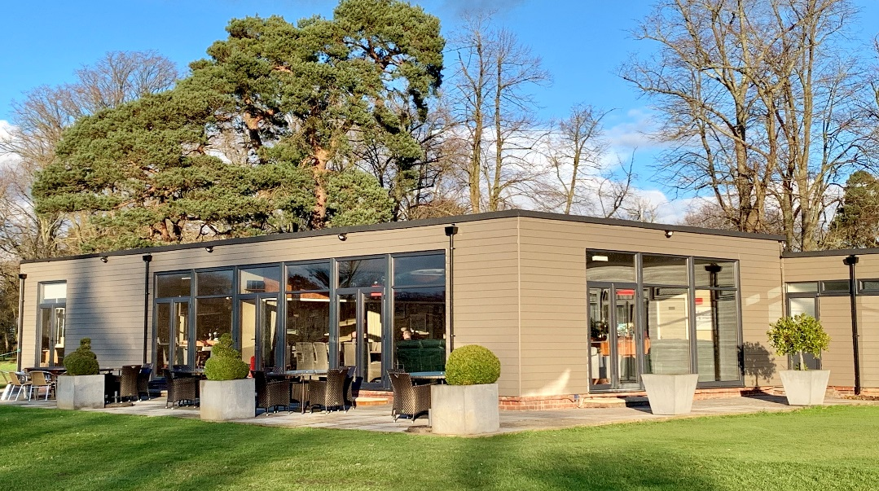

Tee off will commence at 9.00 am

Senior prizes will be given for 1st, 2nd, 3rd, and 4th places for best stableford scores and in addition to this there will be individual prizes for nearest the pin.

Please complete and send off the application form below with your cheque and a stamped addressed envelope if you don’t have an email address. Tee-off times will be e-mailed out w/c Monday 11th July 2022. Cheques payable to ‘Tylney Investments Limited’

Better Ball Stableford 85% of Course handicap allowance, Field limited to 72 Golfers.

To: FAO Paul Archer,
Tylney Park Golf Club, Rotherwick, Nr.Hook, Hants RG27 9AY

Application for the Senior Open Monday 25th July 2022
(Closing date Monday 11th July 2022) £80.00 per pair

NAME ……………………………………………………………………………..

ADDRESS …………………………………………………………………………

EMAIL……………………………………………………………………………...

CLUB……………………………………………………………………………….

CDH NUMBER…………………………………..………………………………...

NAME………………………………………………………………………………

ADDRESS………………………………………………………………………….

EMAIL………………………………………………………………………………

CLUB………………………………………………………………………………..

CDH NUMBER……………………………………………………………………..

ANY DIETARY REQUIREMENTS………………………………………………….

……………………………………………………………………………………….

Please complete the entry form and return by post or email : contact@tylneypark.co.uk
Payment by BACS to Tylney Investments LTD : Sort code : 30-97-41 ACC NO :02066702
REF :Snrs Open.
Payment by cheque made payable to Tylney Investments LTD to address above.

Please tick the box below if you do not wish to be contacted by email in relation to additional golfing events

